|  |
| --- |
| **Set 15. Digital Divide** |

|  |
| --- |
| **Skill 15.01: Explain the global digital divide**  **Skill 15.02: Indicate the causes of the global digital divide**  **Skill 15.03: Explain the geographic digital divide**  **Skill 15.04: Explain the socioeconomic digital divide**  **Skill 15.05: Explain the digital use divide** |

|  |
| --- |
| **Skill 15.01 Explain the global digital divide** |

**Skill 15.01 Concepts**

Many people believe that Internet access should be a basic human right: everyone should have equal access to the information and opportunities available from Internet-connected computers.

Unfortunately, there's an uneven distribution in access to computing devices and the Internet. Some people have no computing device at all, some people have high-speed Internet on their home computer, and many are somewhere in the middle. This difference in access is referred to as **the digital divide** and is often due to socioeconomic, geographic, or demographic factors.

The statistics

Let's start off by looking at the "global digital divide," the differences between all the countries of the world.

This animation of IP address usage in 2013 gives us a feel for the differences in access to the Internet across the globe:



But to really understand the global digital divide, we need to dig deeper and look at the statistics for each country.

This visualization shows the percentage of individuals using the Internet in each country in 2016:

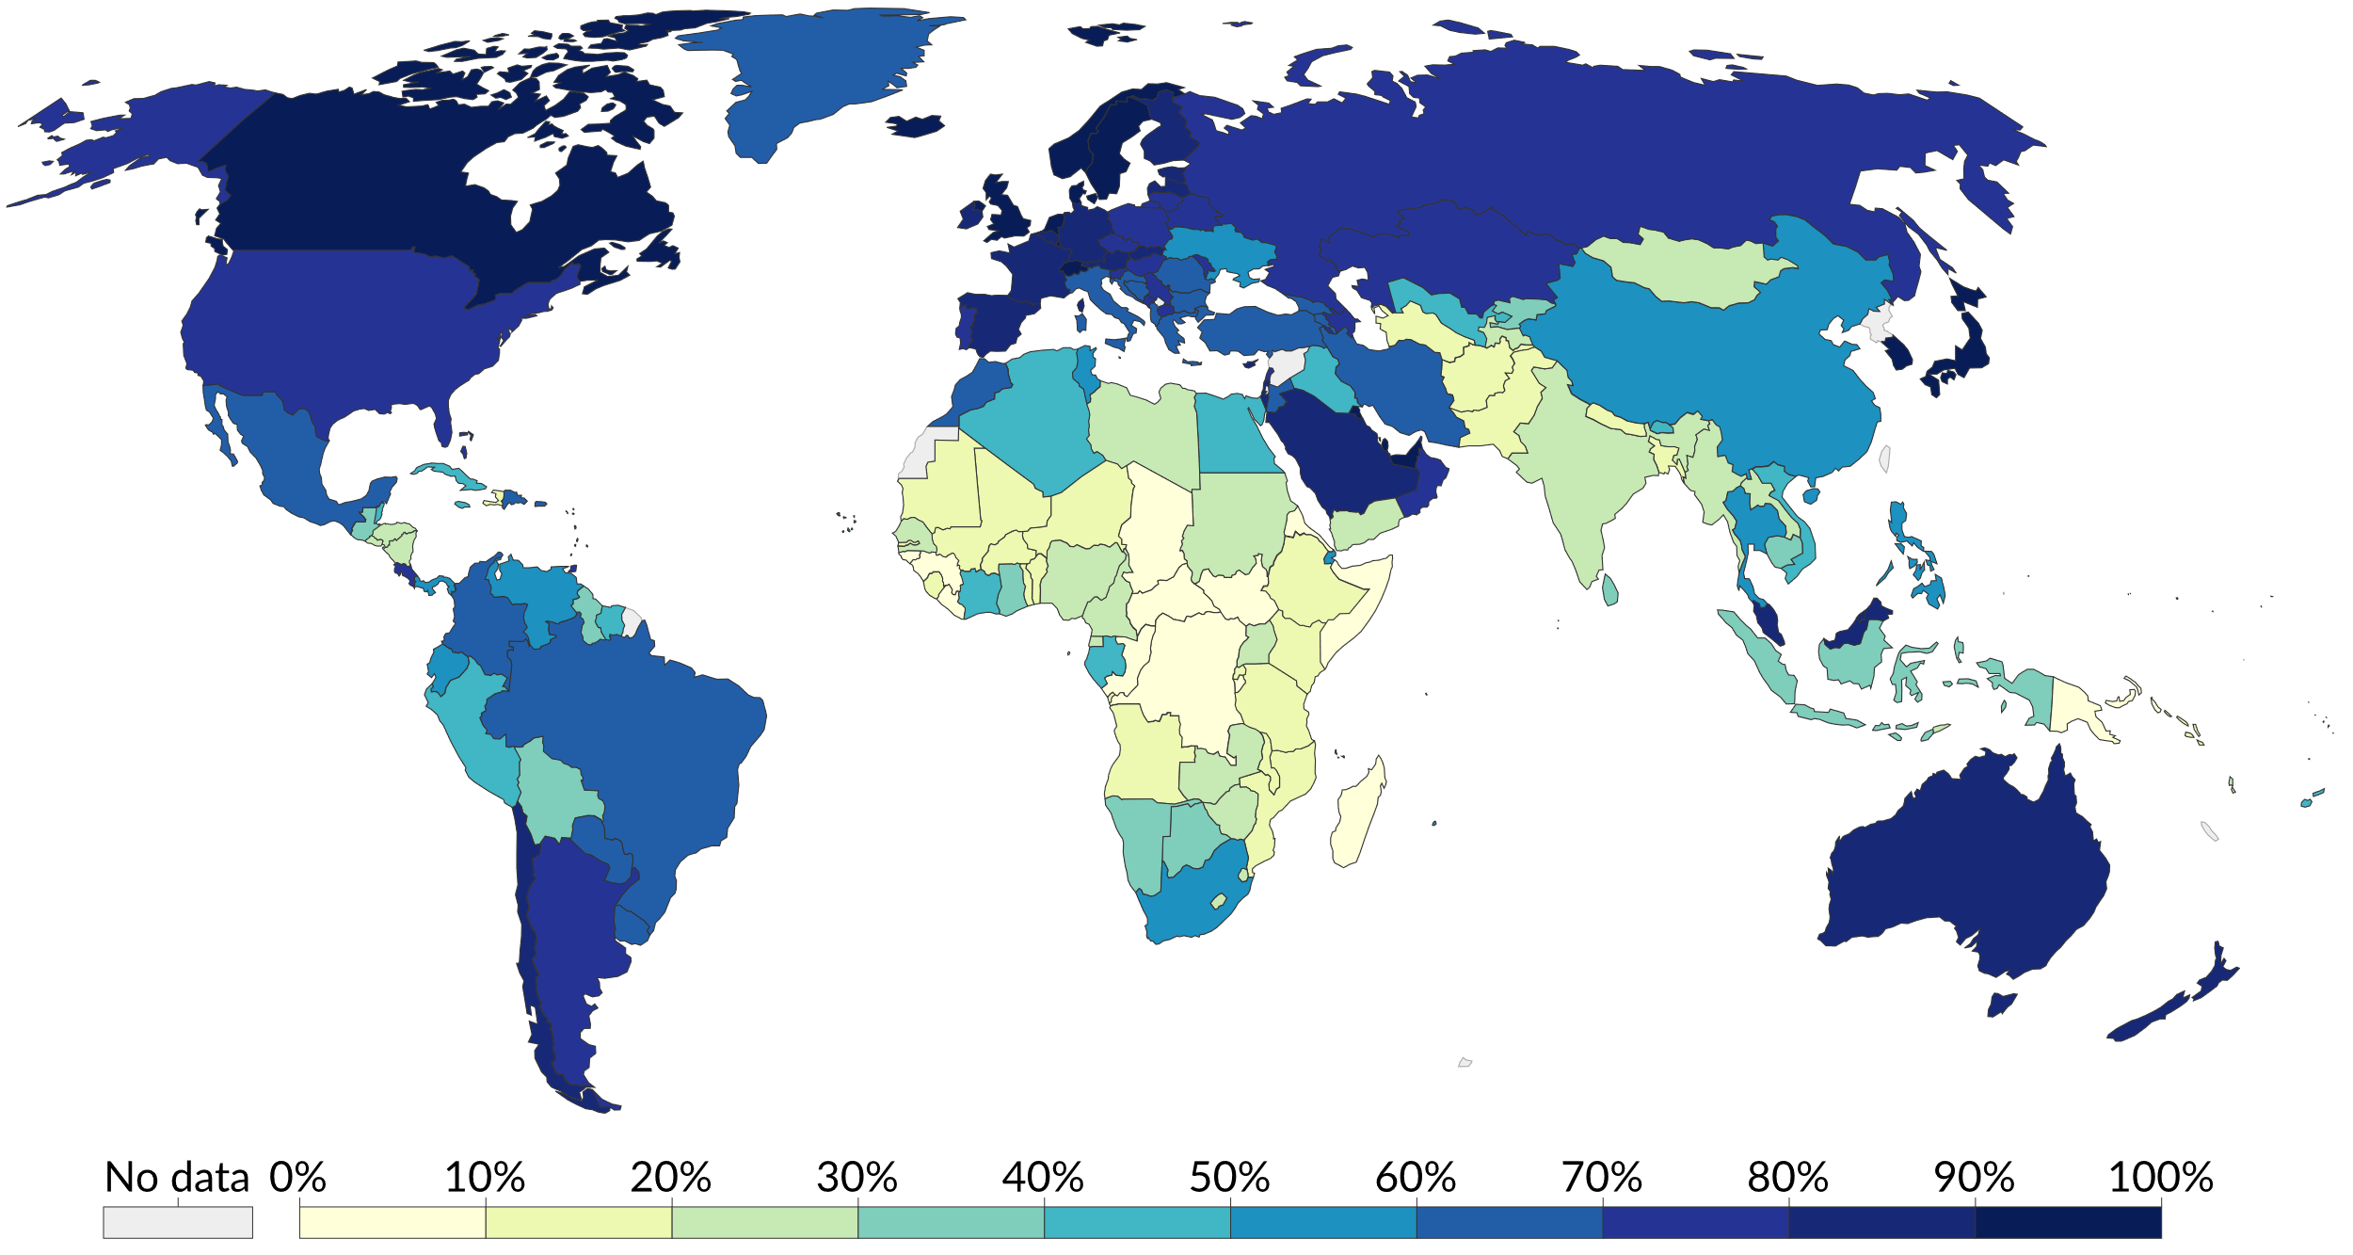

In Norway, **96%** of the population used the Internet. In Somalia, the percentage drops to only **2%**.

This next map visualizes the average speed of Internet connections in each country in 2019:

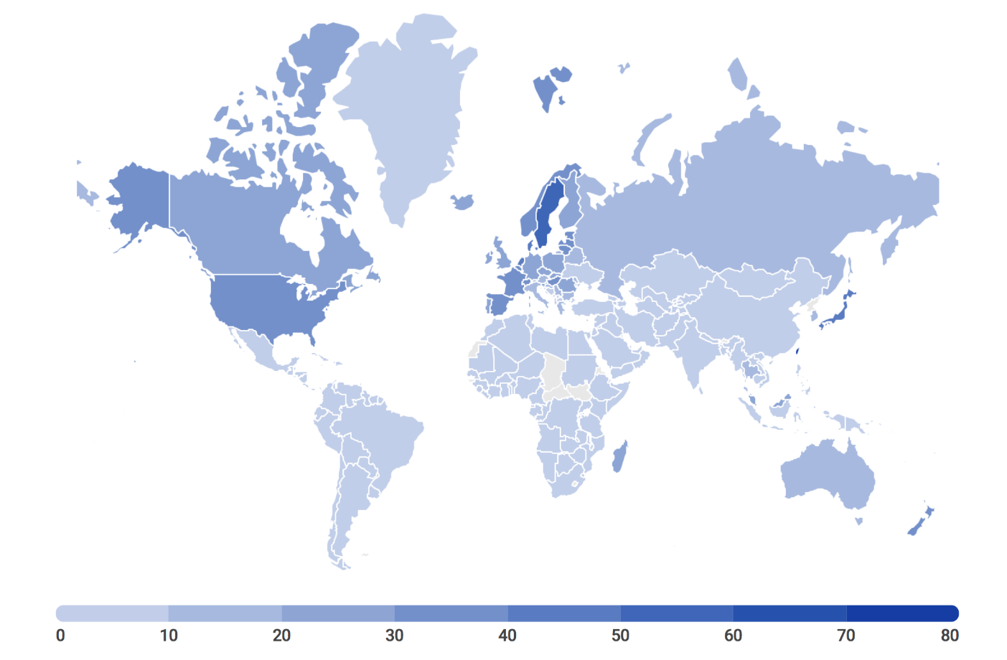

In Yemen it would take an average of **30hrs, 1 minute and 40 seconds** to download a 5GB movie. In Taiwan, it would take only **8 minutes**.

|  |
| --- |
| **Skill 15.02 Indicate the causes of the global digital divide** |

**Skill 15.02 Concepts**

For every country, the infrastructure needed for high-speed Internet is an economic investment, either by the government or by Internet carrier companies. Why is it that some countries or companies make that investment, and others do not?

The most obvious answer is money: not all countries have the budget to build Internet infrastructure. But there are other factors at play as well.

Geography

Internet connections require physical infrastructure; cables between connected buildings and cables connecting one geographic region to the greater Internet.

Multiple geographic factors make it harder to wire up a country:

**A large country.** Taiwan has the highest average speed in the world but it's also one of the smallest countries. Brazil has a low average speed but is also *237 times larger* than Taiwan; they need more physical infrastructure to cover all that area.

**An island nation.** Tonga is a nation of 76 islands in the Pacific. They had very slow Internet speeds until 2013, when a 514-mile fiber cable was installed. When that cable was accidentally severed by a ship, the islands lost Internet for 12 days. Small island nations often have less connections to the Internet than large land-locked nations.

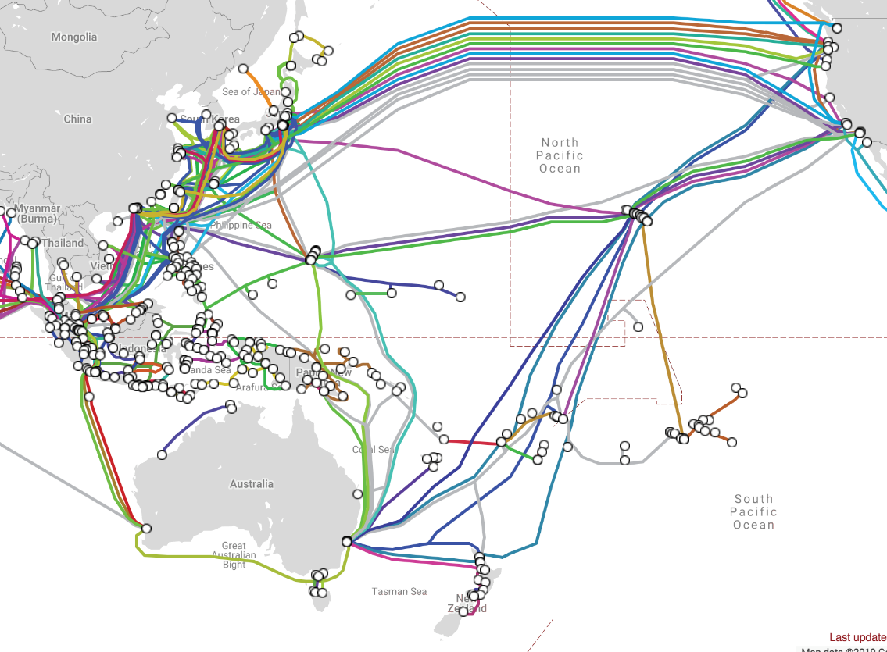

**Difficult terrain.** In the country of Nepal, residents can easily find high speed Internet in the capital city of Kathmandu. However, it's much harder to bring the infrastructure to the many mountainous regions of Nepal, so the average Internet speed is still quite slow.

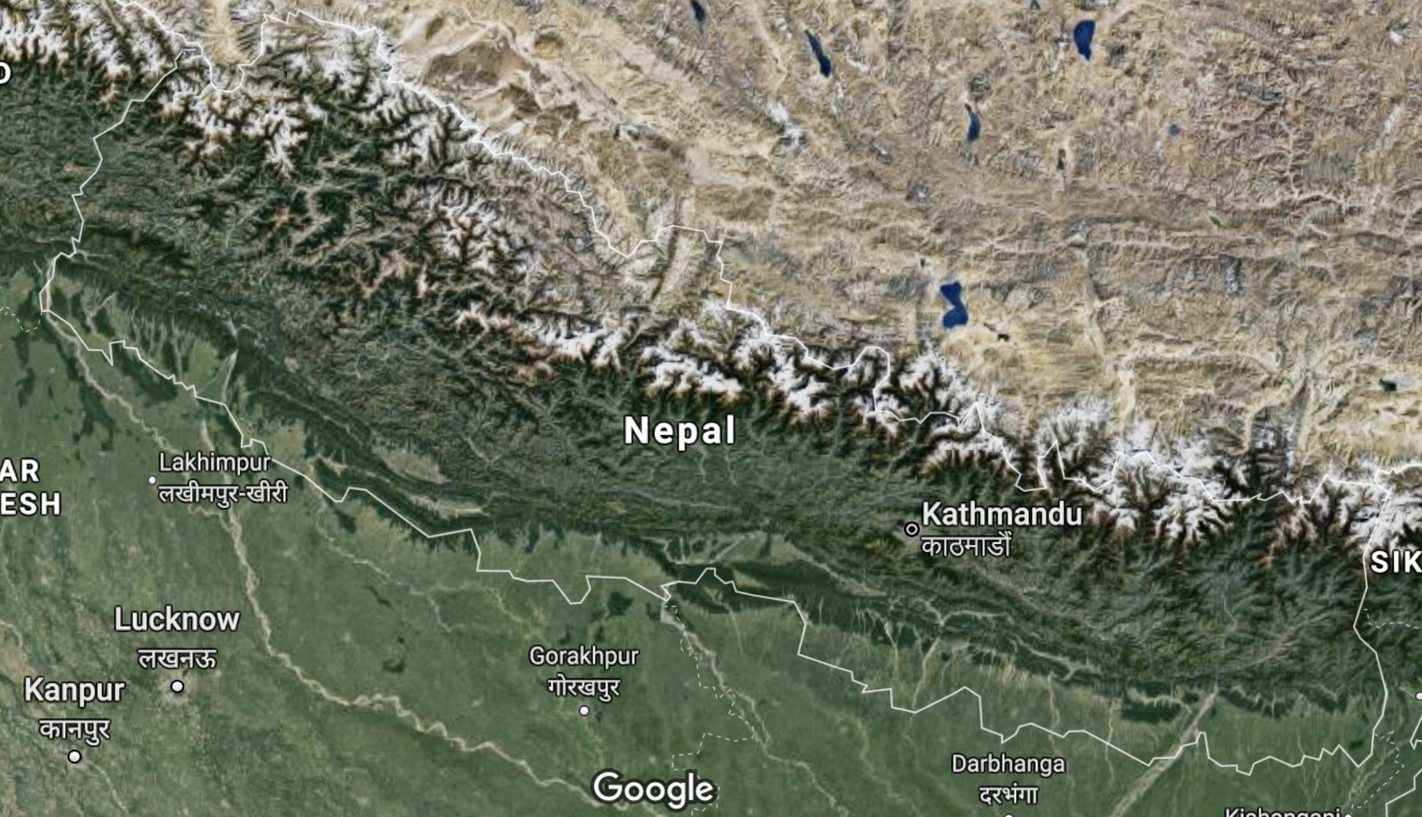

Government restrictions

The Internet is a powerful vehicle for communication and freedom of expression, empowering its users to communicate with other people across the globe and express their opinions. Sadly, some governments feel threatened by that freedom of expression and take efforts to restrict access to the Internet.

The country of North Korea has been almost entirely cut off from the global Internet for the entirety of its existence. In 2015, Secretary of State John Kerry remarked that North Korea had the "lowest rate of access in the world and the most rigid and centralized control."

**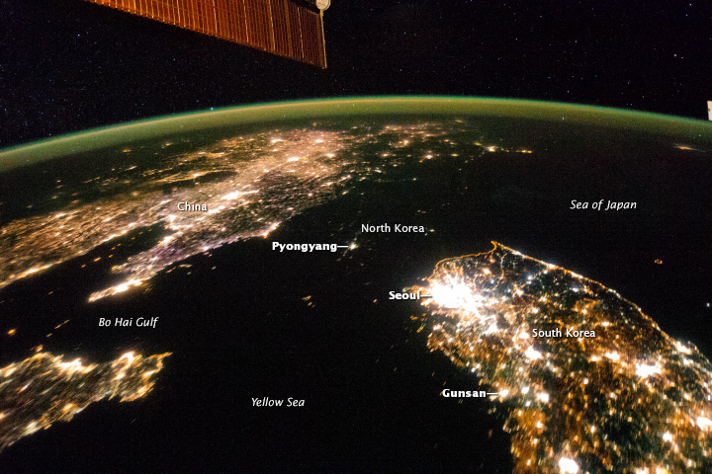**

There is just one Internet Service Provider in North Korea, and that ISP is a joint venture between the North Korean government and a Thai company. There are only 1,024 IP addresses allocated to that ISP, limiting the number of possible connections between North Korea and the rest of the Internet. Access to the Internet is said to be restricted to government officials and foreigners.

As of 2016, there were only 28 publicly available websites hosted on North Korean IP addresses, compared to more than a million websites from the neighboring South Korea.

**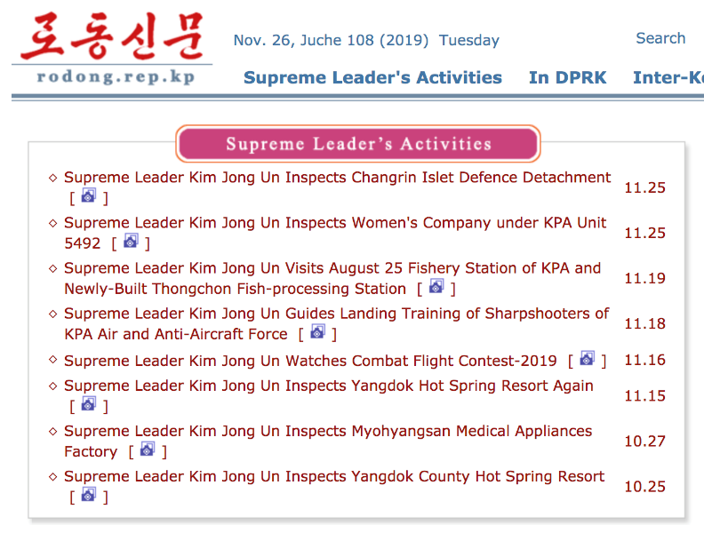**

According to sources inside North Korea, there is a nation-wide intranet called Kwangmyong that provides access to a few thousand websites. Since there are very few computers outside the capital city of Pyongyang and most of the computers there are found in government-controlled buildings, it's estimated that only 10% of the population has even used Kwangmyong.

Since there is no easy way to communicate with North Korean citizens, we don't know how many North Koreans know about the existence of the global Internet and how much larger it is than their local intranet.

Internet shutdowns

In other countries, governments are finding ways to shut down an already booming Internet, particularly during times of civil unrest.

In November 2019, the country of Iran shut down access to the Internet after a series of protests about rising fuel prices. NetBlocks.org monitored the network connectivity in Iran and found that access hovered around 5% for five days.

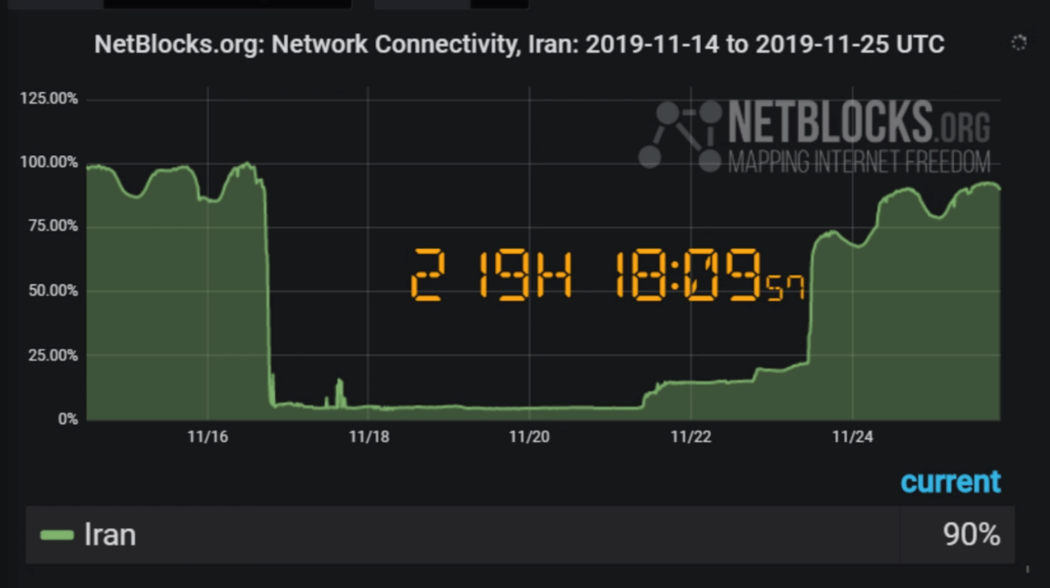

NetBlocks.org called the Iranian shutdown "the most severe disconnection tracked by NetBlocks in any country in terms of its technical complexity and breadth."

Since Iran is a large country with multiple ISPs and Internet protocols are designed to be fault-tolerant, it isn't easy to simply shut off the Internet. The initial dips in the chart above may have been the first attempts by Iranian ISPs to bypass their own system's fault-tolerant recovery mechanisms.

Internet kill switches

Some countries are nervous about how difficult it is to shut down the Internet and are trying to implement a "kill switch", a single shut-off mechanism for the entire country's Internet traffic.

Russia is one country that's made recent progress towards a kill switch, with a 2019 law that allows the government to shut down access to the Internet "in an emergency."

To make a kill switch technically feasible, the law requires all ISPs to route traffic through government-controlled points and to install software that can monitor and filter traffic using "deep packet inspection" technology. Russia also plans to build its own DNS system, so that it is no longer dependent on foreign hosted DNS servers to resolve domain names.

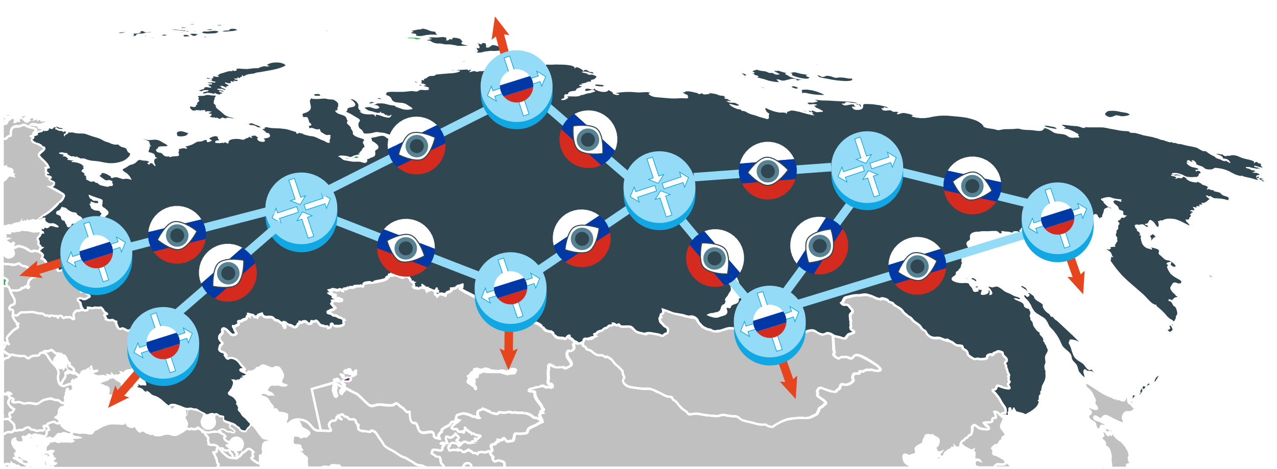

If the Russian government succeeds, then they will both be able to shut off their citizen's access to the global Internet while maintaining access to Russian hosted websites. Russian council chairman Leonid Levin says:

“It's more about creating a reliable Internet that will continue to work in the event of external influences, such as a massive hacker attack.”

Not all the citizens of Russia are convinced, however. When the law was first drafted in March, a series of protests broke out over Russia. Activist Sergei Boiko said this to one of the protesting crowds:

"The government is battling freedom, including freedom on the Internet, I can tell you this as somebody who spent a month in jail for a tweet."

**[Skill 15.02 Exercise 1](https://hpluska.github.io/APCompSciPrinciples/ticketOutTheDoor/set15/Set15TicketOutTheDoorAPCompSciPrinciples.pdf)**

|  |
| --- |
| **Skill 15.03: Explain the geographic digital divide** |

**Skill 15.03 Concepts**

We often think of the digital divide in terms of the global digital divide, the marked difference in Internet connectivity speeds and access to computers between the nations of the world.

But within each nation—even nations with relatively high connectivity—the infrastructure of the Internet is not distributed equally. This map from the FCC visualizes the 2018 availability of broadband providers with ≥ 100 Mbps download speeds:

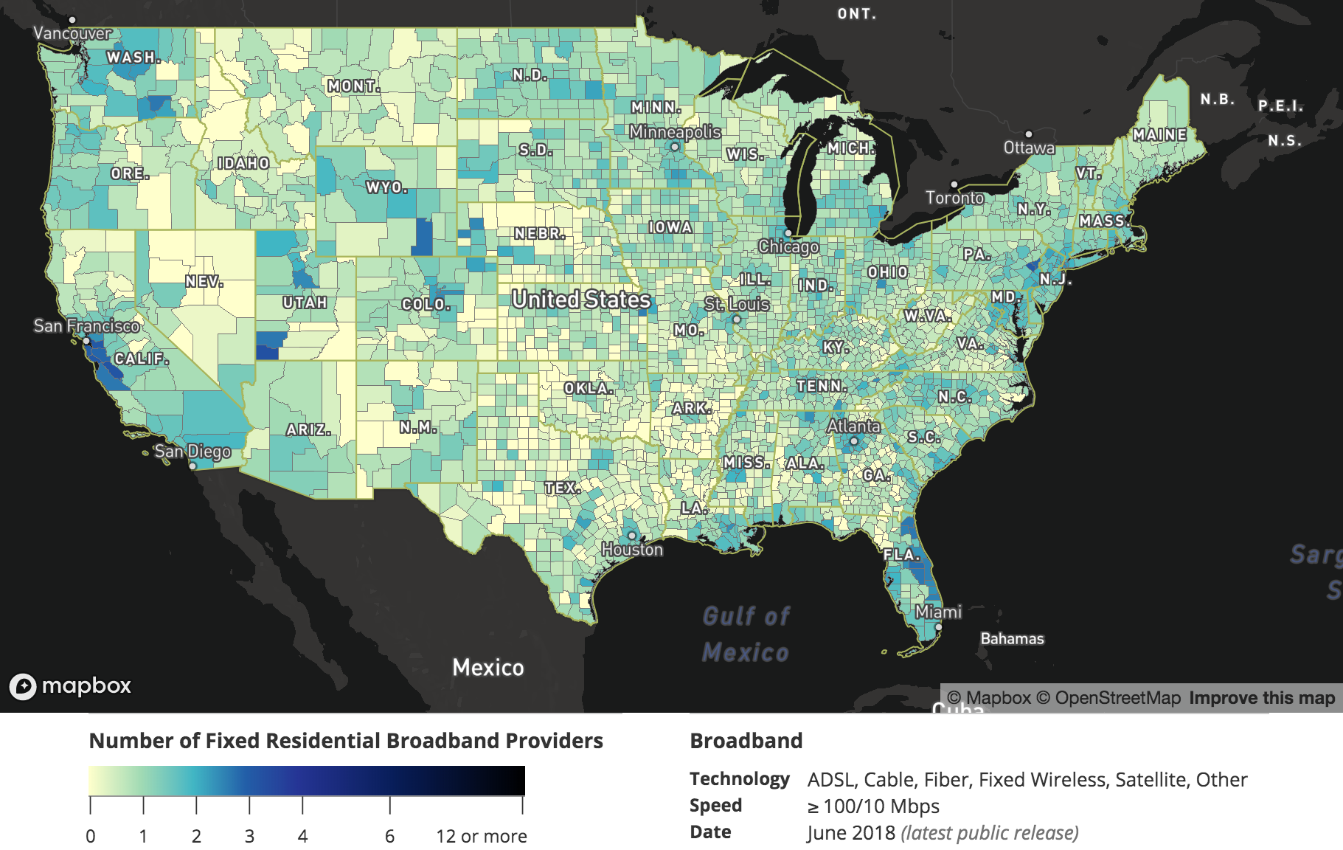

Urban vs. Rural

Consider this table of statistics on the amount of people in various US regions that lacked access to 25 Mbps broadband Internet connections in 2014:

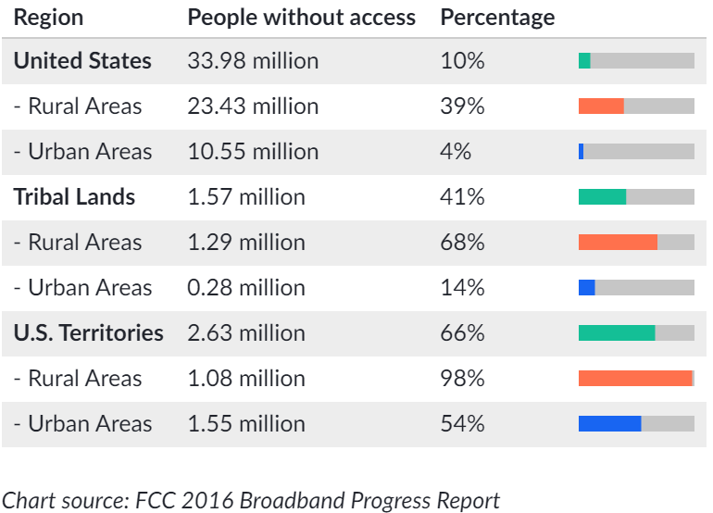

Across all the regions, there was a sizable gap between urban and rural areas. Why the gap? We can hypothesize a few reasons:

* The areas in a country with the most difficult terrain are often rural areas, since the terrain does not make it easy to build dense urban structures. That terrain makes it similarly tricky to lay down cables.
* Internet Service Providers are typically for-profit companies in the US, and they can make more profit in urban areas where there are many more paying customers and less cable to lay down.
* ISPs can also charge less when it's easier to recoup the costs, so the same speed Internet connection in an urban area might cost $40 monthly but cost $100 monthly in a rural area.

What can be done about it?

In the US, the FCC Connect America program has allocated $1.488 billion dollars in funds to expand broadband access in rural areas. ISPs use the funds to build out the infrastructure for better Internet access in rural areas and tribal lands.

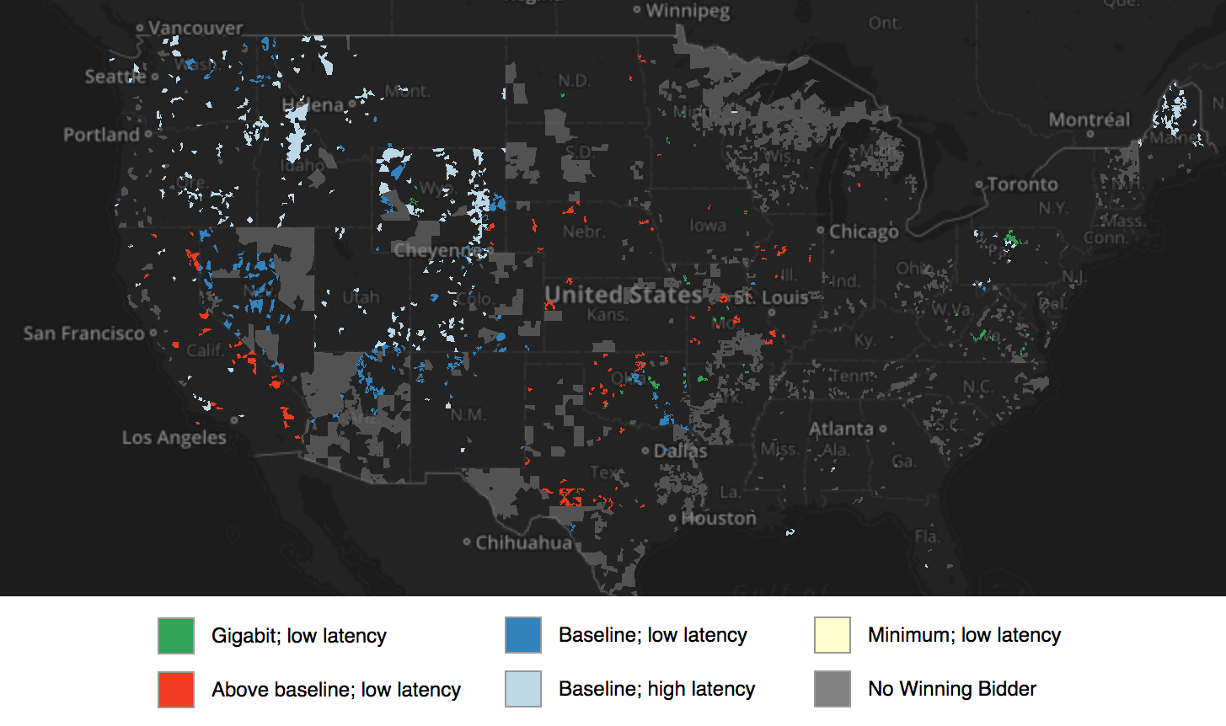

In the UK, frustrated rural citizens took matters into their own hands—literally!—and created a non-profit called Broadband for the Rural North (B4RN). They ask citizens of rural communities to buy shares in B4RN and use the capital from those funds to install local infrastructure themselves.

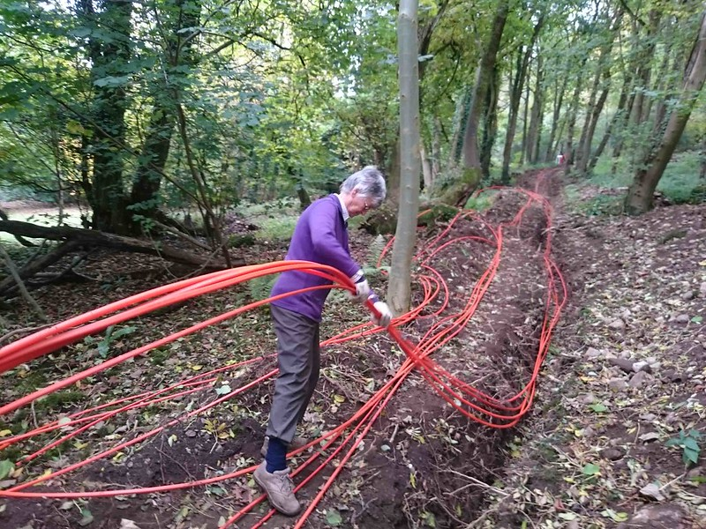

**[Skill 15.03 Exercise 1](https://hpluska.github.io/APCompSciPrinciples/ticketOutTheDoor/set15/Set15TicketOutTheDoorAPCompSciPrinciples.pdf)**

|  |
| --- |
| **Skill 15.04: Explain the socioeconomic digital divide** |

**Skill 15.04 Concepts**

Fortunately, there are many regions around the world that now have the infrastructure necessary for high-speed Internet. However, even within a region that is well connected to the Internet, we still find differences in which households have access to computers and the Internet. Those differences are often due to socioeconomic factors.

Income inequality

Consider this chart that compares home access to digital technologies across different income groups in the US:

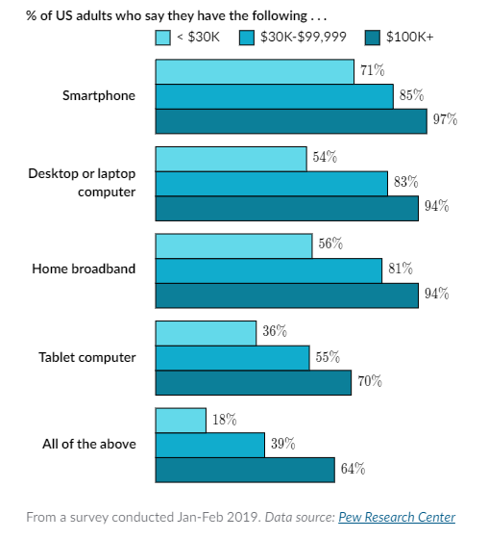

In the lowest income group, households earning less than $30,000, nearly 50% reported that they did not have a computer or broadband in their home.

Those without home computers have to use a smartphone or public computer lab instead when they want to utilize online services. For example, a 2014 study found that 32% of low-income smartphone owners used their phone to submit job applications, compared with just 7% of higher-income smartphone owners.

The effect of socioeconomics on homework

This digital divide also affects the next generation of job seekers—students just trying to get their homework done at home. Teachers are increasingly assigning homework with digital tools and students have to find a way to complete those digital assignments. (Are any of you reading this as part of a homework assignment right now?)

Consider these charts about teenagers and homework completion:

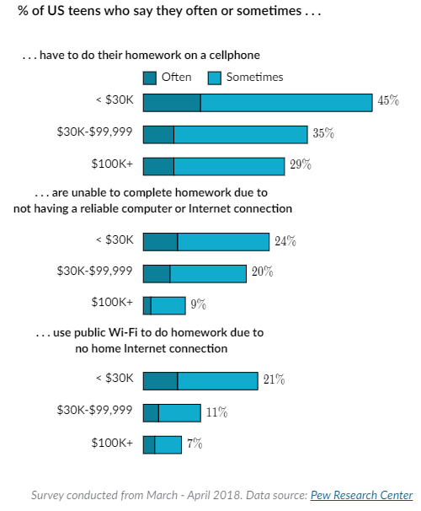

In low-income households, students are much more likely to complete homework on their phone, use public Wi-Fi to complete it, or be unable to complete it due to lack of a reliable computer or connection. The statistics are similarly low for Black and Hispanic households.

According to a report by the Wall Street Journal, the fast food restaurant McDonald's is a popular place for students to complete their homework assignments, thanks to its free Wi-Fi, many locations, and late hours.

Efforts to bridge the socioeconomic divide

Many organizations are attempting to bridge the divide for low-income individuals, especially students.

**Governments**: The state government of Maine started a 1-to-1 computing initiative in 2002, giving laptops to every 7th and 8th grader in Maine schools.

**Non-profits**: [ConnectHomeUSA](https://connecthomeusa.org/" \t "_blank) is a project bringing computers, connections, and digital literacy training to people living in subsidized housing. [GiveInternet](https://giveinternet.org/" \t "_blank) is an international non-profit that raises money to give laptops, Internet connections, and digital training to underserved high school students.

**Internet Service Providers (ISPs)**: For-profit companies are also getting involved in helping to bridge the digital divide. Comcast Internet Essentials offers low-cost Internet connections for eligible low-income households, while Sprint started the 1Million Project Foundation, an effort to give one million high schoolers a wireless Internet connection and computing device.

|  |
| --- |
|  |
| <https://www.nbcchicago.com/top-videos-home/race-in-chicago-covid-19-exposes-a-digital-divide/2340216/> |

|  |
| --- |
| **Skill 15.05: Explain the digital use divide** |

**Skill 15.05 Concepts**

The digital divide is about more than just having access to an Internet connection and a computer; it's also about how well you're able to utilize those tools.

Researchers find large differences in how effectively various groups of people can use digital technology. Those differences are often referred to as the **digital use divide**.

Digital literacy

Basic digital literacy includes the ability to use input and output devices (such as a mouse, keyboard, or touch screen), an understanding of the structure of the digital environment (what files, folders, scrollbars, links, menus, and buttons mean), and the ability to interact with digital information (knowing how to save, delete, open, or select).

A 2012 research study evaluated the basic digital literacy skills of US adults. Consider the results by age group:

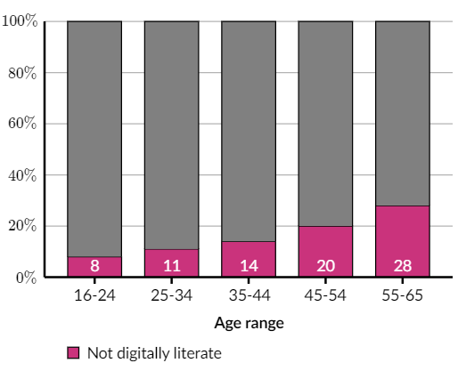

The study found significant differences in digital literacy across age ranges, and also found differences across educational levels, country of birth, ethnicity, employment, and occupation skill level.

The study found significant differences in digital literacy across age ranges, and also found differences across educational levels, country of birth, ethnicity, employment, and occupation skill level.

Basic digital literacy skills are a great start, but they may not be enough to fully utilize digital resources. Researchers studied a program that taught computer basics to participants and concluded:

" . . . future implementation of the Computers for Families program should not only include a ‘boot-camp’ basic computer training, but also ongoing and progressive trainings that will enhance participants’ skill sets. For example, those interested in working within an office setting could greatly benefit from typing classes as well as learning about software such as Microsoft."

Digital literacy is a spectrum. Once someone can navigate a computer, can they also . . .

* navigate the Web?
* send and receive emails?
* use a word processing application?
* use a spreadsheet application?
* search for and apply to a job?
* use social media safely?
* research topics online?

Increasing digital literacy

Many efforts to bridge the digital divide also include digital literacy training, and there are specific initiatives devoted entirely to teaching people how to use computers effectively.

One example is SFConnected, a government-sponsored program in San Francisco that connects senior citizens with free digital literacy classes in multiple languages, with a particular focus on using online tools to decrease social isolation.

Here's what one man said after participating in the program:

“You wouldn’t believe the freedom I felt — the handcuffs came off! A computer compresses distance: you can visit people without owning a car.”

Effective use of technology in the classroom

There's also a digital use divide in classrooms. Even though two classrooms may both have the same computer hardware and speed of Internet access, one classroom might report that technology is increasing their learning while the other classroom reports the opposite.

How can digital technology benefit classroom learning? It can:

* Offer differentiated instruction (different materials for each student based on their strengths and weaknesses)
* Provide a way to monitor students' progress to teachers and parents
* Open up a portal to a vast array of knowledge for research projects
* Give students more multimodal ways to interact with content

How can digital technology detract from classroom learning? It can:

* Give students an easy way to distract themselves (with social media, entertainment, and communication apps)
* Use up valuable classroom time to troubleshoot mechanical problems
* Take time away from other forms of learning that may be more beneficial than the computer-assisted instruction
* Take funding away from other areas that may improve the classroom experience, such as an additional teacher's aide

What is it that determines whether technology benefits or detracts? Hundreds of research studies have tried to figure it out.

One study looked at California schools that received funds to improve their Internet connectivity. The researchers did find an increase in connectivity rates at those schools, yet no effect on test scores or academic outcomes. Another study of Portugal schools found negative effects on learning for schools that were closer to the broadband provider (and likely had faster speeds).

Researchers are also interested in the effects of laptop programs, such as the Maine Laptop initiative that gave a laptop to every 7th and 8th grader. The standardized test scores of those students haven't increased, but their writing scores seem to have improved. A similar study of a laptop program in Peru found no effect on math or language skills, but some improvement in cognitive skills.  Internet-connected computers can be used in many ways, of course. The ultimate test of digital technology is whether a classroom using software specifically designed for improving learning does, indeed, improve learning.

One study in 2009 evaluated 10 reading and math tools across elementary, middle, and high school, and only found a positive effect for one reading tool. However, another 2009 study found positive effects for urban districts using software for pre-algebra and algebra, particularly in larger classrooms.

Studies of computer-aided instruction in developing countries tend to find larger positive effects. One 2010 study of students using personalized learning software in Ecuadorean schools found positive gains in their math scores, and a 2014 study in China schools using math-based computer games also found that students' math scores increased.

We're still just beginning to understand how digital technology can enhance classroom learning, but it clearly is possible. Hopefully, in the future, all classrooms will know how to use computers and the Internet effectively.

The digital participation gap

Internet-connected computers aren't just devices for consuming content, they're also devices for creating content. In fact, the web showcases the digital creativity of millions of creators. But who are those creators? When we dig into the statistics, we discover a participation divide: differences between who is consuming digital content and who is actually producing it.

OpenStreetMap is a crowd-sourced effort to create a map of the entire world, free for anyone to use and to update. In theory, its contributors could reflect the diversity of the general Internet population.

After signing up, you can edit the map using a free online interface, no download needed:

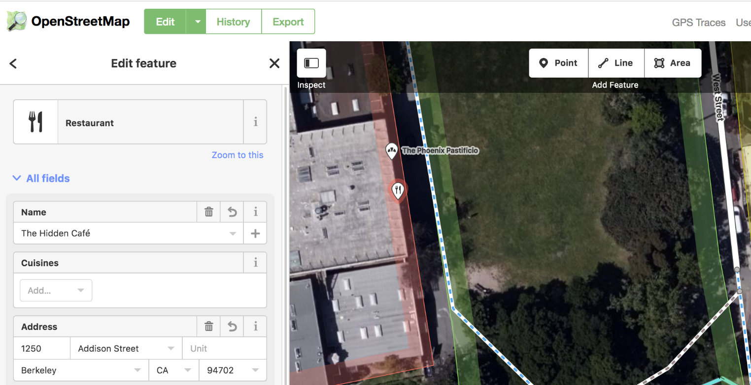

Screenshot of the OpenStreetMap interface for editing a feature.

But researchers have found disparities in who edits the map and what parts of the world get attention from editors.

A 2019 study found that edits aren't evenly distributed geographically by gender. All US counties were edited by at least one male "power editor," but only a fraction of counties was edited by one of the female power editors. These are shown in red below,

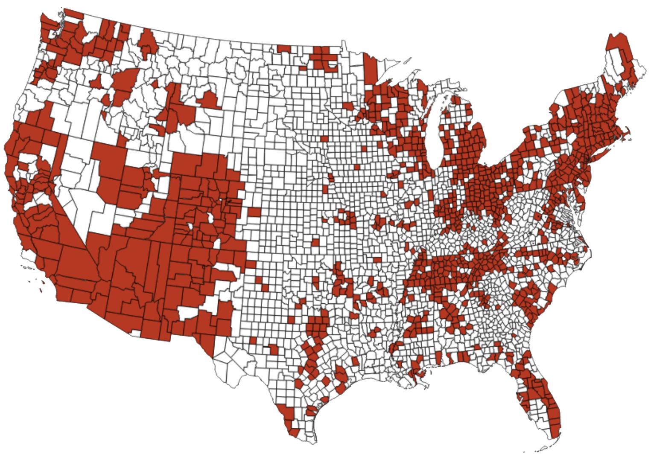

The researchers also found that only 5% of the editors overall were female, a statistic that correlates with other studies on OpenStreetMap.

The participation divide on OSM is consistent with other sites like Wikipedia.

Narrowing the participation gap

How can an online collaborative project like OSM bring in more diversity so that every part of the world is mapped to a consistently high standard?

GeoChicas is one group that is actively trying to discover women’s barriers to participation and increase their contributions. Its members organize trainings, attend conferences, and work on special projects such as La Calles de Las Mujeres.

Missing Maps is a project that focuses on mapping the most vulnerable areas of the world in OpenStreetMap so that humanitarian agencies can use the maps to help them during crisis situations.

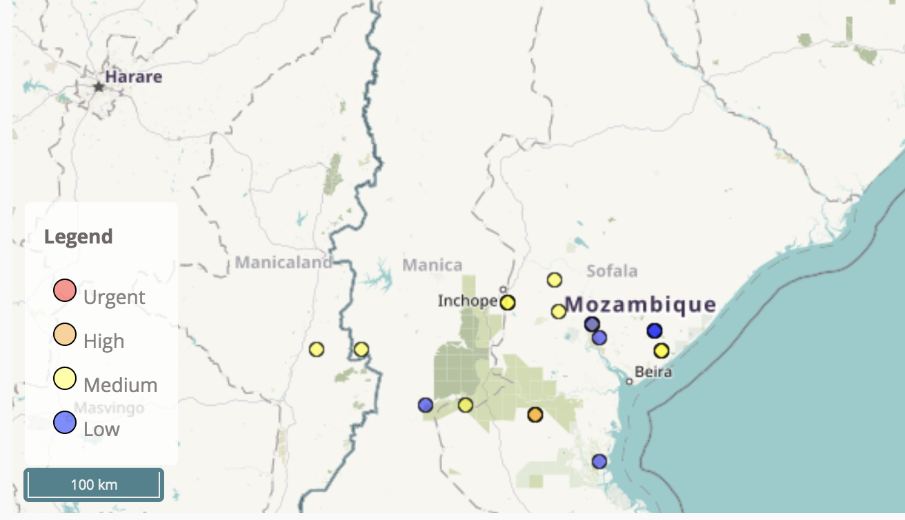

The organization encourages mapathons to get a large number of people working on a project at one time. Mapathons can also bring new people into the community, since they include training and a welcoming social setting.

Online crowd-sourced content often reflects the bias of its contributors. As long as there's a difference in who contributes and how they contribute, online content will not reflect the diversity of the web.

**[Skill 15.05 Exercises 1 thru 3](https://hpluska.github.io/APCompSciPrinciples/ticketOutTheDoor/set15/Set15TicketOutTheDoorAPCompSciPrinciples.pdf)**